ENHANCING ARCHITECTURAL DESIGN EDUCATION THROUGH GENERATIVE AI: A COMPARATIVE STUDY OF STUDENT PROJECTS BEFORE AND AFTER AI INTEGRATION

M. Yehia¹, F.N. Michael¹ and C. Danial²

ABSTRACT

Abstract— As digital technologies rapidly evolve, architectural education must adapt to prepare students for emerging professional realities. This study investigates the impact of integrating Artificial Intelligence (AI) and Virtual/Augmented Reality (VR/AR) into the design education of undergraduate architecture students.
A selected group of 15 students from the Higher Institute of Engineering in El Shorouk received training in using advanced tools such as SketchUp, Revit, Twinmotion, Enscape, and AI applications. These technologies were applied during their graduation project development.
The research adopts a comparative approach, assessing student projects before and after the integration of these tools. Evaluation criteria included creativity, functionality, technical accuracy, and aesthetics. Initial assessments were conducted by faculty members, and final reviews were performed by an external jury of distinguished Egyptian architecture professors.
Findings indicate a marked improvement in students’ design performance and academic achievement, emphasizing the value of AI and VR/AR in enhancing architectural education. This integration fosters innovation, improves visualization, and better equips students with the digital skills required for contemporary architectural practice.

Keywords: Generative Artificial Intelligence (AI), Architectural Design Education, Building Information Modeling (BIM), Twinmotion, Enscape, Virtual Reality (VR), Design Studios, Student Performance, Design Creativity, Design Pedagogy, AI Integration, Visual Representation, Environmental Responsiveness.

INTRODUCTION

Architectural design studios have historically constituted the core of architectural pedagogy, serving as the primary venue for students to cultivate creativity, experiment with spatial solutions, and develop professional competencies. The graduation project, in particular, is widely recognized as the culmination of architectural education, embodying a student’s intellectual and technical maturity. Nevertheless, the rapid technological transformation of the built environment necessitates a parallel transformation in architectural education. Conventional design processes—centered on drafting, physical modeling, and basic digital tools—are increasingly inadequate for addressing the complex demands of sustainability, digital fabrication, and data-driven design.
Over the past two decades, emerging technologies such as Building Information Modeling (BIM), parametric design, and digital simulation tools have begun to reshape architectural workflows. More recently, AI has introduced a paradigm shift, offering capabilities in generative design, environmental simulation, performance optimization, and automated evaluation. When combined with immersive technologies such as VR and AR, AI expands the boundaries of architectural education by enabling interactive exploration, real-time feedback, and context-aware decision-making. This study addresses a critical question: How can the integration of AI, VR, and AR technologies enhance the quality of architectural education, particularly at the level of graduation projects?

____________________________________________________________
¹ Department of Architecture, Faculty of Engineering, El Shorouk Academy, El Shorouk City, Egypt
² Department of Architecture, Faculty of Engineering, Delta Higher Institute for Engineering & Technology, El-Dakahlia, Egypt
* Corresponding Author

II. METHODOLOGY

The study adopts an applied comparative methodology designed to capture both qualitative and quantitative impacts of integrating AI, VR, and AR technologies in architectural education. The methodology unfolds across five interrelated stages:
- Theoretical Framework Development**: A systematic literature review was conducted to examine existing studies on AI, VR, and AR applications in architecture and design education. This provided the conceptual foundation for developing evaluation criteria.
- Evaluation Criteria Design**: Based on the literature, structured criteria were formulated covering creativity, functional planning, technical accuracy, aesthetic value, sustainability, and communication skills. These served as benchmarks for assessing student performance.
- Student Training Program**: Out of 130 final-year students at the Higher Institute of Engineering in El Shorouk, 15 volunteered for intensive training in the Virtual Reality Lab. The training involved mastering AI-powered design assistance, 3D modeling in SketchUp and Revit, real-time rendering with Twinmotion and Enscape, and immersive visualization through VR/AR platforms.
- Pre-Integration Evaluation**: Students’ initial graduation project outputs were assessed by nine faculty members using the established criteria. Scores were documented as baseline data.
- Post-Integration Evaluation**: After completing training and integrating AI/VR/AR into their workflows, the students’ final projects were evaluated by an external jury composed of senior professors. Comparative analysis was conducted to measure improvement across all criteria.

- Relative Weights of Evaluation Criteria

Criterion | Weight Before (%) | Weight After (%) | Remarks
Design Concept Quality | 20 | 18 | Conceptual clarity supported by AI data
Analysis & Field Study | 15 | 17 | Enhanced by AI-driven data analysis
Planning & Organization | 15 | 16 | Improved with space optimization algorithms
Technical Accuracy | 10 | 15 | Strengthened via BIM integration
Aesthetic Aspects | 10 | 10 | Stable emphasis on artistic sensibility
Presentation Tools | 5 | 10 | Shift towards VR/AR immersive tools
Sustainability | 10 | 8 | Refined by AI simulations
Communication | 10 | 10 | Remains essential skillset
Compliance | 5 | 6 | Improved through digital documentation

Evaluation of Graduation Projects Before and After the Integration of Artificial Intelligence and Virtual/Augmented Reality (VR/AR) Technologies
At this stage of the study, the graduation projects of undergraduate architecture students will be evaluated using the previously proposed assessment criteria, both before and after the integration of artificial intelligence and virtual/augmented reality (VR/AR) technologies into their final projects. The following steps were undertaken:

- At the beginning of the academic year, a detailed lecture was delivered to the students about the integration of artificial intelligence technologies with advanced architectural software such as SketchUp and Revit, along with 3D simulation and visualization tools like Twinmotion and Enscape. The lecture emphasized the transformative role of virtual and augmented reality technologies in reshaping the structure and practices of architectural education. These technologies contribute to the development of design tools and the reformation of the design process, making it more intelligent, interactive, and flexible. They rely on data analysis and real-time responsiveness, thereby enhancing the efficiency of architectural designers in contemporary environments.
- Students were consulted regarding their willingness to participate in an experimental application of AI and VR/AR technologies in their graduation projects. Hands-on training was provided in the Virtual Reality Lab at the Higher Institute of Engineering in El Shorouk, under the supervision of a selected team of faculty members and teaching assistants involved in the graduation project course.
- Out of 130 enrolled undergraduate architecture students, 15 students expressed their interest in joining the experimental training and integrating these technologies into their projects. Accordingly, these students underwent a full academic year of training in AI tools, SketchUp, 3D simulation and visualization software (Twinmotion and Enscape), and VR/AR technologies.
- By mid-academic year, the students’ performance on their graduation projects was evaluated before the integration of these technologies. Nine faculty members specializing in graduation project supervision assessed the 15 students using the previously proposed criteria. The average scores were calculated and documented in the students' coursework grade sheets.
- During the second half of the second semester, a comprehensive evaluation of the students was conducted by a committee consisting of two faculty members involved in teaching the graduation project course, provided that neither of them was a direct supervisor of the students under evaluation. The average of the two members’ assessments was adopted as an indicator for measuring the students’ performance in employing digital technologies within their design outcomes.
- After completing the training, the students applied these technologies to develop and enhance their graduation projects.
- At the end of the academic year, the graduation projects were re-evaluated and discussed by an external jury composed of prominent professors of architecture in Egypt. This jury conducted a second evaluation of the projects after the integration of AI and VR/AR technologies. A comparative study was then conducted between the students’ grades before and after the integration.

III. RESULTS OF APPLIED STUDY

The analysis of student performance across the three stages—Pre-Integration, During Training, and Post-Integration of AI technologies—reveals a consistent and measurable improvement in architectural design skills and related competencies.
- Overall Performance Improvement: All students demonstrated an upward trend in their total performance scores across the stages. The average total score increased from approximately 81.3 (Pre-Integration) to 87.1 (During Training), and further to 91.3 (post-Integration), indicating a significant enhancement in both conceptual and technical aspects of design due to the integration of AI tools in the educational process.
- Design Concept Quality: Students showed incremental improvement in their design thinking. The average score improved from 16.3 (Pre) to 16.5 (Post), reflecting enhanced creativity and problem-solving capabilities as a result of AI-assisted ideation tools.
- Analysis and Field Study: This criterion recorded one of the highest gains. The average score improved from 12.1 to 15.4, suggesting that AI tools helped students better analyze site conditions, user needs, and contextual factors.
- Planning and Interior Organization: Students became more proficient in spatial planning, with average scores improving from 12.2 to 14.8, showing that AI applications like space optimization and smart layout generation contributed to better functional design solutions.
- Technical Accuracy in Drawings: A sharp improvement was observed, from an average of 8.1 (Pre) to 13.6 (Post), indicating that AI-assisted drafting tools significantly reduced errors and enhanced precision.
- Aesthetic and Artistic Aspects: Scores rose from 8.2 to 9.1, reflecting students’ increased ability to experiment with materials, styles, and visual composition using AI-powered rendering and visualization tools.
- Use of Presentation Tools: This dimension saw a marked improvement—from 4.1 to 9.2—which underscores the role ofAI in enhancing communication and visual storytelling capabilities in design presentations.
- Sustainability and Environmental Considerations: Sustainability-related evaluations showed progress (from 7.6 to 8.5), suggesting that AI tools encouraged eco-conscious decision-making by simulating energy usage, daylighting, and material impact.
- Presentation and Communication Skills: Scores improved from 7.8 to 9.1, attributed to the use of intelligent tools that helped students organize and deliver their ideas more clearly and effectively.
- Academic and Organizational Compliance: The scores in this area rose from 4.2 to 5.6, indicating better adherence to submission guidelines and academic standards, possibly supported by AI in documentation and task management.

- Evaluation of Graduation Projects Before and After Technology Integration

Criterion | Average Score Before | Average Score After
Design Concept Quality | 16.3 | 16.5
Analysis & Field Study | 12.1 | 15.4
Planning & Organization | 12.2 | 14.8
Technical Accuracy | 8.1 | 13.6
Aesthetic Aspects | 8.2 | 9.1
Presentation Tools | 4.1 | 9.2
Sustainability | 7.6 | 8.5
Communication Skills | 7.8 | 9.1
Academic Compliance | 4.2 | 5.6

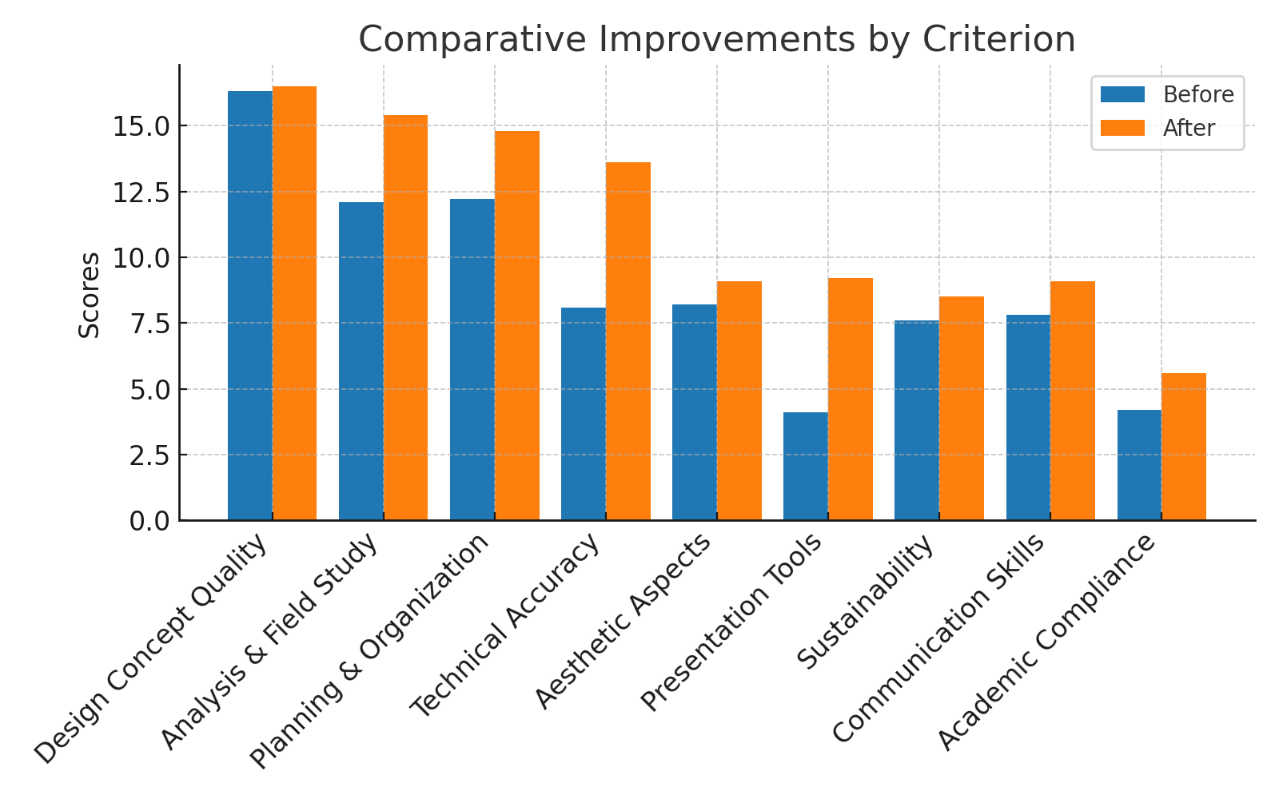
Figure 1. Comparative Improvements by Criterion

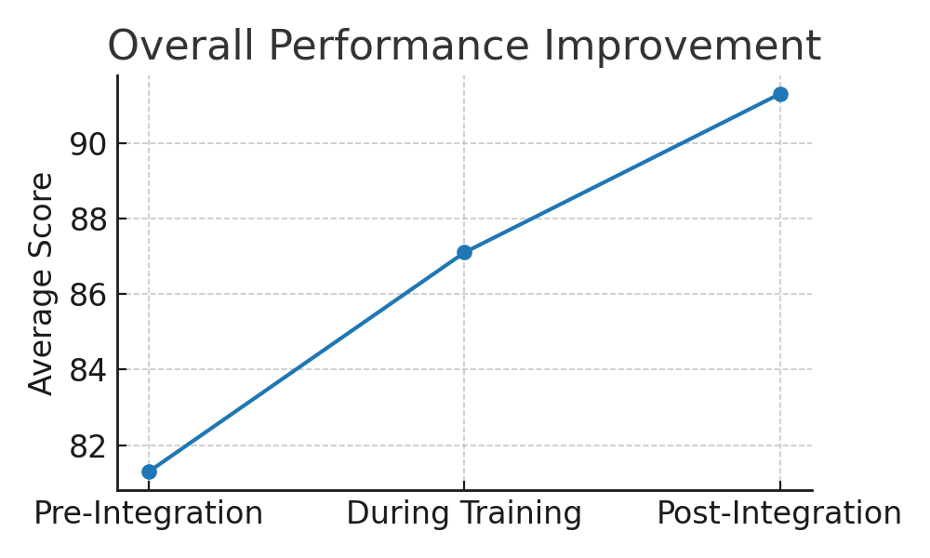
Figure 2. Overall Performance Improvement
Pre-Integration
During Training
Post-Integration
Average Score
90
88
86
82
84

- The results of the study indicate substantial improvements across multiple dimensions of design education. Average performance scores increased significantly between the pre-integration and post-integration phases. Specific findings include:
- Design Concept Quality: Students demonstrated greater creativity and contextual awareness, moving from conventional concepts to innovative solutions informed by AI-assisted ideation tools.
- Analytical Depth: Integration of AI-enabled environmental analysis improved students’ capacity to address site conditions, user requirements, and sustainability concerns.
- Spatial Organization: AI-supported space optimization tools enhanced the logic and functionality of interior layouts.
- Technical Precision: The transition from 2D drawings to detailed 3D BIM models significantly improved accuracy, reducing design errors.
- Presentation and Communication: Immersive VR/AR presentations enriched communication with jurors and simulated real-world client interactions.
- Sustainability Considerations: Students increasingly adopted eco-conscious strategies supported by AI-based energy and daylighting simulations.

IV. Discussion

The findings of this study align with global discourse on digital transformation in higher education. AI enhances design thinking by enabling generative approaches, predictive analytics, and performance-driven iteration. VR and AR extend this transformation by bridging digital models with real-world spatial experiences. Together, these technologies create a comprehensive digital ecosystem that enriches architectural pedagogy.
In the Egyptian context, where architectural education often grapples with resource constraints and large student populations, the integration of AI and immersive technologies offers unique advantages. It democratizes access to advanced design tools, provides students with immediate analytical feedback, and fosters collaborative, interdisciplinary learning environments. Furthermore, these technologies prepare graduates for regional and global markets where digital competencies are increasingly prerequisites for employment.

Conclusion
The integration of AI, VR, and AR into architectural education constitutes a pivotal step toward aligning curricula with the demands of contemporary practice. The study demonstrates measurable improvements in student creativity, analytical capacity, technical precision, and presentation quality. By embedding intelligent tools into design studios, architectural institutions can better prepare graduates to navigate the complexities of sustainable, data-driven, and technologically mediated design environments.
The research recommends systematic curriculum reform, including the establishment of specialized digital laboratories, interdisciplinary faculty training, and expanded application of AI/VR/AR across all levels of architectural education. Such initiatives will not only enhance educational outcomes but also contribute to the development of future-ready architects capable of addressing the pressing challenges of the built environment in the digital age.

References
[1] Burry, M. (2016). Scripting Cultures: Architectural Design and Programming. Wiley.
Reference to a journal publication with an article number:
[2] Oxman, R. (2017). Thinking Difference: Theories and Models of Parametric Design Thinking. Design Studies, 52, 4–39. https://doi.org/10.1016/j.destud.2017.06.001
[3] Asad, M., & Filip, D. (2020). Integration of VR and AI in Architectural Education. International Journal of Architectural Computing, 18(3), 321–340. https://doi.org/10.1177/1478077120939841
[4] Li, X., & Wang, C. (2022). Enhancing Architectural Design Skills Using Virtual and Augmented Reality. Automation in Construction, 138, 104226. https://doi.org/10.1016/j.autcon.2022.104226
[5] Kolarevic, B. (2003). Architecture in the Digital Age: Design and Manufacturing. Taylor & Francis.

